Those 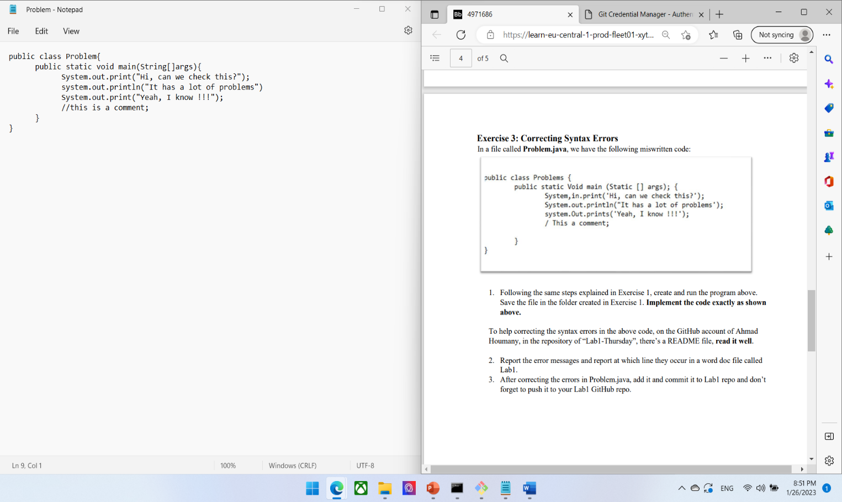

Those are the changes I made:

Changed public class name to match the file name

Changed all prints to system.out.print or println

Changed / to // in order to add the comment